# Modules , Export and Require

## Conceptual Aside : Modules

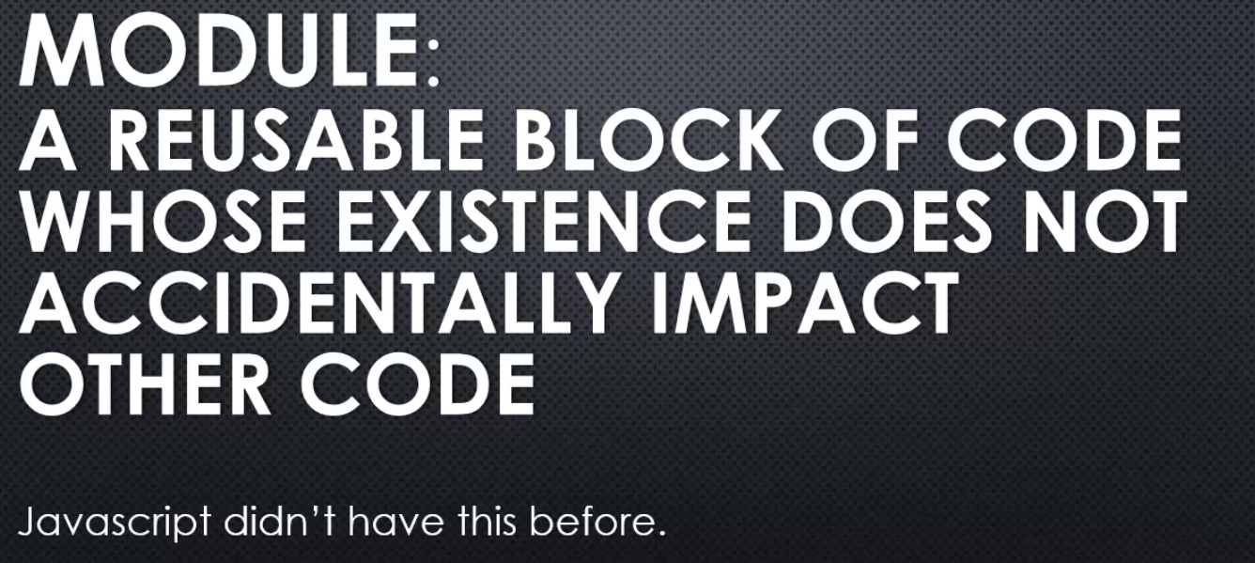

Major programming languages have this feature, and Javascript didn't have this before.

In fact this is a new feature for Javascript in ES 6, the latest version.

However, at the time of NodeJS's creation, Javascript didn't have this.

It did have ways to protect your code to be able to write your code in the module-like format, but it was a workaround. It wasn't an officially supported part or aspect of the language.

**So NodeJS needed to give us the ability to build code modules, reusable blocks where I could put code in that block of code and it wouldn't impact other code in the rest of my application unintentionally.**

**So NodeJS implements something called CommonJS modules.**



You may here the phrase **CommonJS. It's just a set of standards.**

So NodeJS said the way that common JS modules, the way that standard says the way modules should be structured, we agree with that. So we're going to design a way for you to structure your Javascript code in modules that will follow this standard.

## **Javascript Aside : First class function and function expression**

**Concept explained in javascript course – Understanding weird parts**

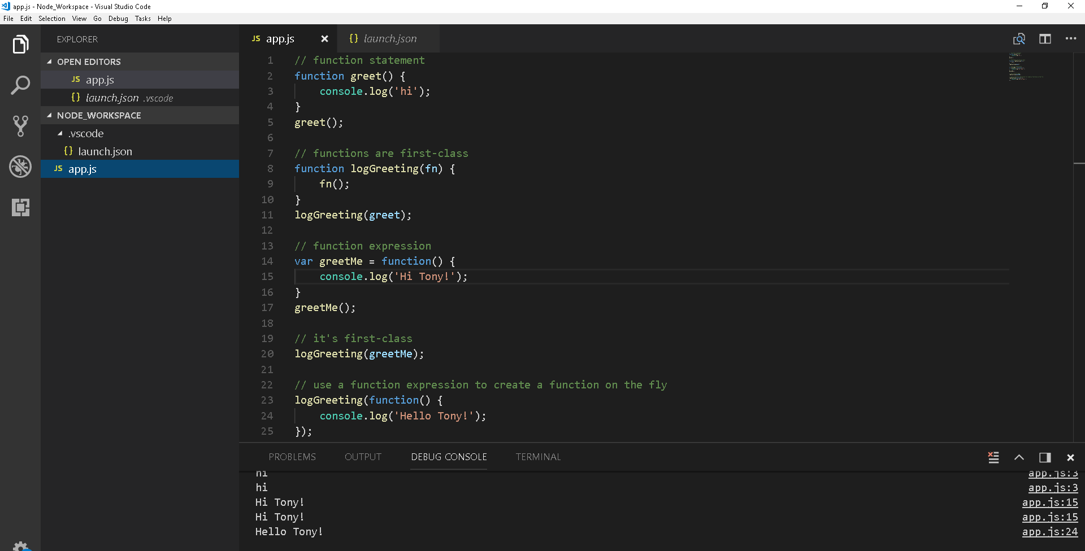

## **Javascript Aside :** Objects and Objects literels

**Concept explained in javascript course – Understanding weird parts**

## Lets build a Module

designed to be independent from the other code and yet working in tandem with it. Something I can reuse, something I can use in other Node programmes, and it's a way for me to keep my code structured. A way to make it more easy to manage as it grows. And even for other developers who are coming in perhaps new to the same project to make it easier for them to understand and find where the code is.

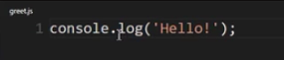

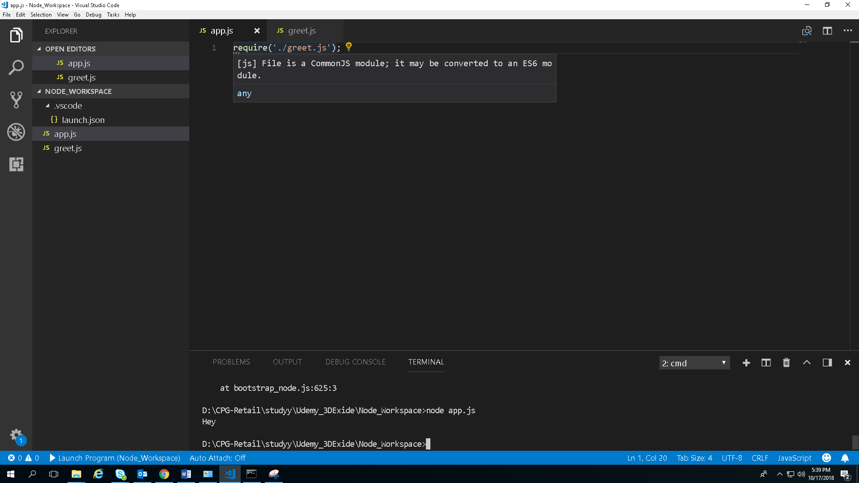

**require is a function that Node makes available inside its javascript core. What you pass to the function, the argument, the parameter is a string, and the string contains the location or the name of the module that you wish to import or that is used.**

**dot slash(./) that I'll put on it means this is in the same location as the javascript file that I'm sitting in right now, at the same folder level.**

Output - 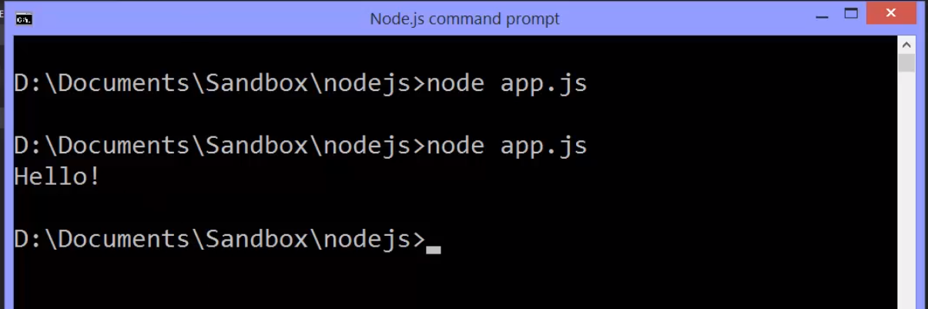

**This means Node grabbed this file and executed the javascript file, pushed it through the V8 engine in its own custom code and it ran, just like that.**

Another way of greet.js by wrapping the hello msg in function So we'll use a function expression: var greet.and calling it. It will work.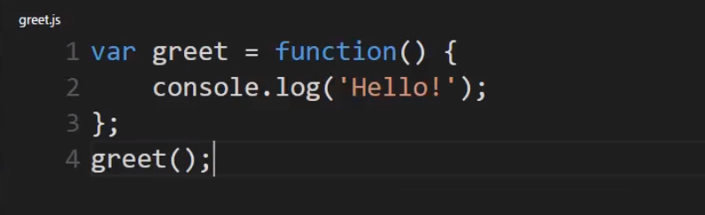

**But now, app.js has loaded this module. Does that mean I can call greet from app.js?**

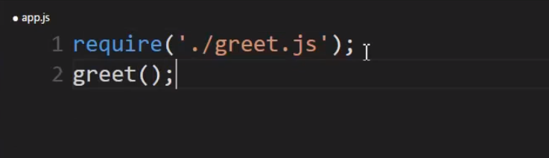

No, greet is not defined.This is by design.

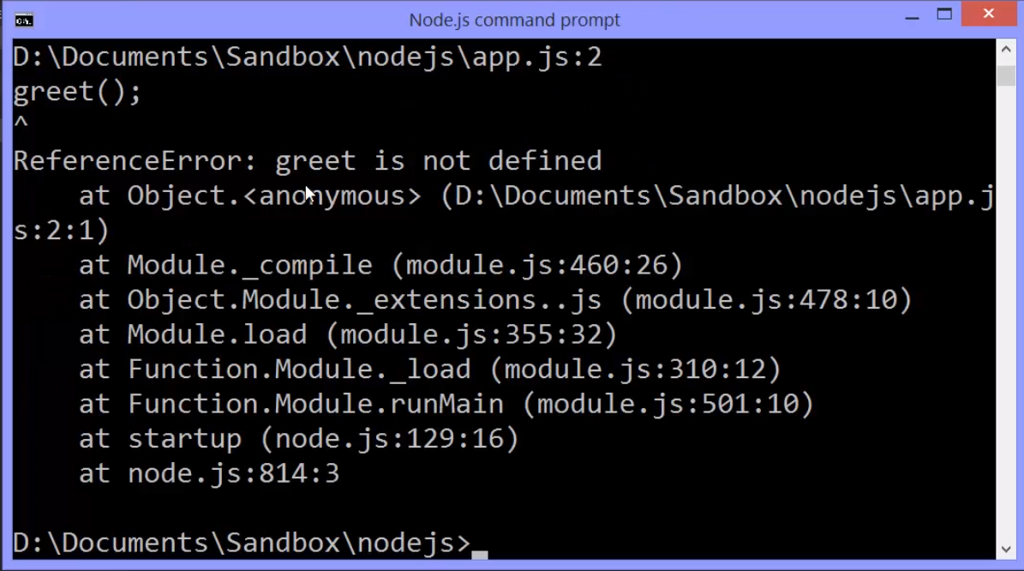

**The code inside greet.js is protected. App.js doesn't simply have access to it unless I want it to. It can't go get its variables, its functions, its objects. We would have to explicitly make that available.**

Node js provides a way to do this.

In my **module I can simply type: module.exports. This is a special variable, a special object, a special place to put things that I want to make available to anything else that uses this module, and only the things I attach to this will be made available.**

**So I choose what becomes available outside.**

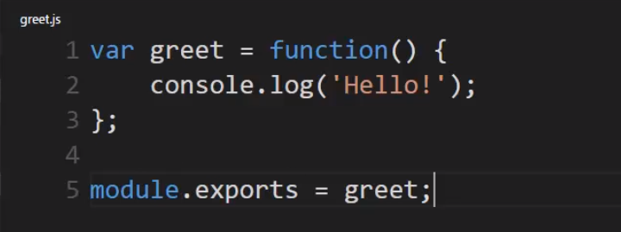

Now, this module is exposing the greet function.

So how can I use this in my app.js file?

Well, I can actually set a variable equal to the results of the function.

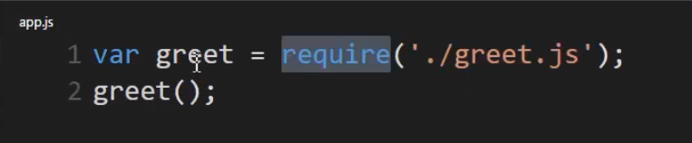

So the require function will return, module.exports. So I can just call it the same name if I want or I could call this a different name

The set equal to the results of require and require will give me back whatever I've attached to module.exports to my module.

**So Node js says: ah, you want the greet.js file, it runs it and then gives me back whatever I've attached to this special phrase: module.exports.**

Remember functions are first class so I can set them equal to a variable and then invoke the function using that variable name.

**What's also kind of neat is I can actually remove this dot js extension. Node js's require function is smart enough to know that if I'm asking for a module it most likely is a javascript file, because this is Node js we're talking about. So I could run this and it still works. It knew that when I said greet, I actually meant greet.js.**

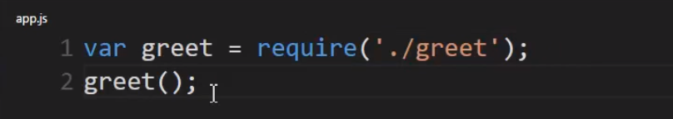

So you might be asking yourself:

well **where did require and module, module.exports, where did those come from?**

**Well they're defined inside a javascript core.**

Then you might ask: well how did it become available to my javascript files, and how is it that the module protects my variables, my code that I don't have access to them outside the module unless I explicitly expose it with module.exports?

Well actually there's a few variables going on. Let's go ahead and go into the module and I'll run it with a breakpoint, here at module.exports.

Let's launch it.

There, now I want you to notice something. Here are all the variables available to me, right now.Obviously there's the greet function. I created that. But there's also module, require, exports, dirname, filename.

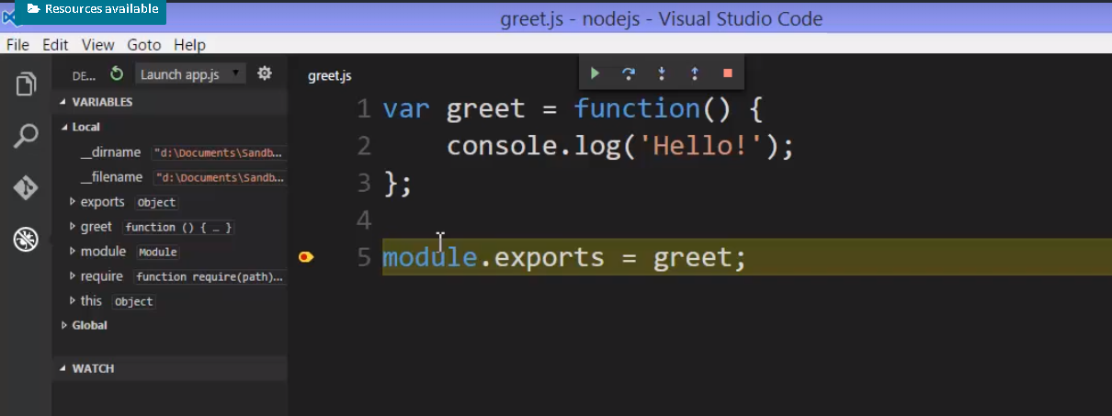

Where did those come from?

**The this variable always is setup and available to me, but that's the V8 javascript engine. The javascript itself, the ecmascript standard, the specification says that there should be a this keyword which can mean different things depending on what function and what code you're running, but this is always available.**

**However, require, module, exports, filename, dirname,**

**those aren't part of the ecmascript specification. They aren't part of javascript and they're available to me here even though I haven't typed them into my code.What do they do exactly and where do they come from?**

Understanding how modules really work will help you to write better ones, and help you to see all the patterns that you can use and organise in your code in a clean and reusable way.

So that's what we're going to see next. We're going to see exactly how modules and require work in Node js.

## How do node Modules actually works : Module.Exports and Require

The nice thing is that require is a JavaScript function, and even though it exists in the JavaScript side of the Node core, we can actually step into it and see the JavaScript that is running as it's running. And, this will help us understand what's really going on.

I'll step into the function. So, let's step in, and here we are inside the JavaScript side of the Node core.

I'm in a file called **module.js,** which is just one of the JavaScript files that's built into Node. And, we can see that I'm actually inside the require function.

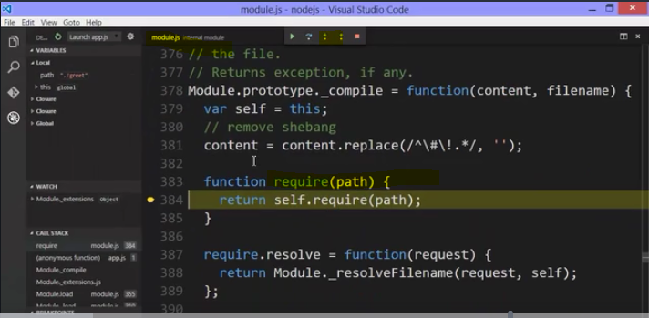

**This require function itself is actually just returning what comes back from the real require function, which I'll step into, which is sitting on the prototype attached to this function constructor module. So, in other words, every module you create gets an object created to represent it, and that has access to a require method using prototypal inheritance.**

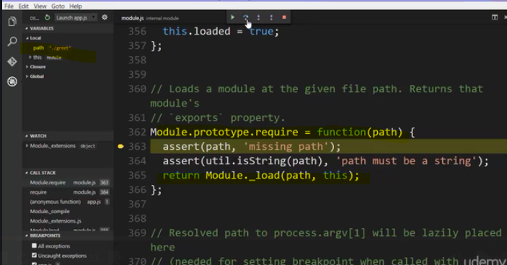

it's actually just a wrapper for a load function.

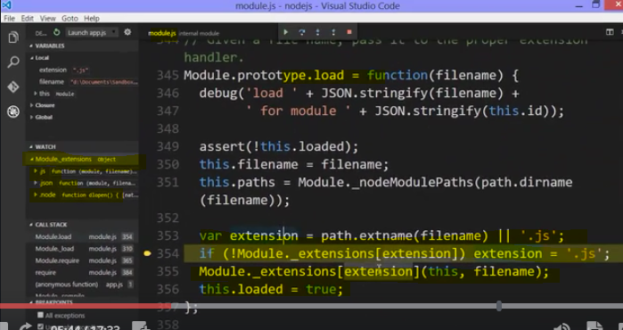

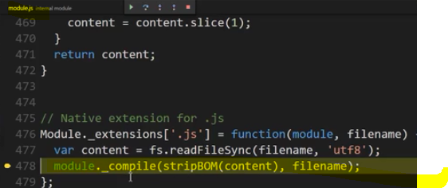

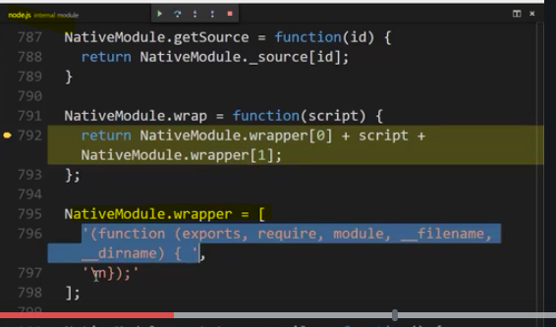

And so on, you can check as I check by debugging.

**The require function finished running. It went out, got the file, it assumed it was a .js file, loaded the contents, wrapped it, ran it, and then returned whatever came sitting on module.exports, the exports property of the module object.**

**When I wrote my greet.js file I have some code. Node runs this, but rather than simply running this code through the V8 engine, it wraps it inside a function expression using those parentheses to create that function on the fly. And, this function expects five parameters.**

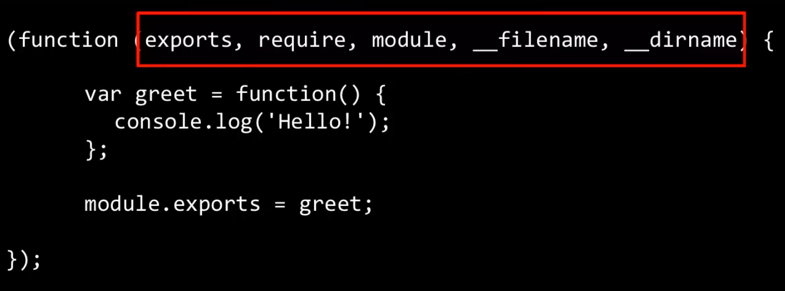

You might be wondering what the first one is, exports. We'll ignore that for now,

**but it also expects a require parameter, a module parameter, a filename, a directory name, and we saw these things being created. So then, Node actually invokes the function, passing the things that are expected, the filename, the directory name, the module object, making the require function available to my code, because it's passed in in reality as a parameter when the code is actually executed. And, the same thing with module.**

**Module is available to my code when I'm writing in Node, because my code isn't what's actually the only thing that's run. My code is wrapped in a function, and that module is a parameter to that function, and Node passes it in.**



**And, the last thing to note is what actually is returned then from require is module.exports.** Remember that objects are passed by reference. So, whatever I do to module.exports inside my module, because it's inside the function, is going to impact the module.exports that was created outside the function.

So, require gives me this module object, and then I change the module object by changing what's on .exports. And then, that means that when require gives back module.exports, when it returns it from itself as a function, whatever I did inside my module to module.exports, whatever I did inside my module code to this module object that's what will be returned by require, because its pass by reference it's pointing at the same object in memory. And so, in that way, I'm exposing, I'm making available features via module.exports that are protected inside this function. And, that's also why the code that I write is protected. Because of function scope in JavaScript.

**My code is actually wrapped in a function, which means the variables that I create, the functions I create inside there are protected inside that function. They're not available outside.**

**But, because of passing by reference, because the module object is passed by reference I can then use that as my window to outside my function. So, I can change the module, and because it's pointing at a memory space that's available outside my function, I can change it, and that change becomes available outside this secretly wrapped function.**

Alright, so this is how this is really working, and remember, it's that module.exports. That's really what's coming back from require. So, you need to change module.exports in your code, and that's what's going to be given back from require.

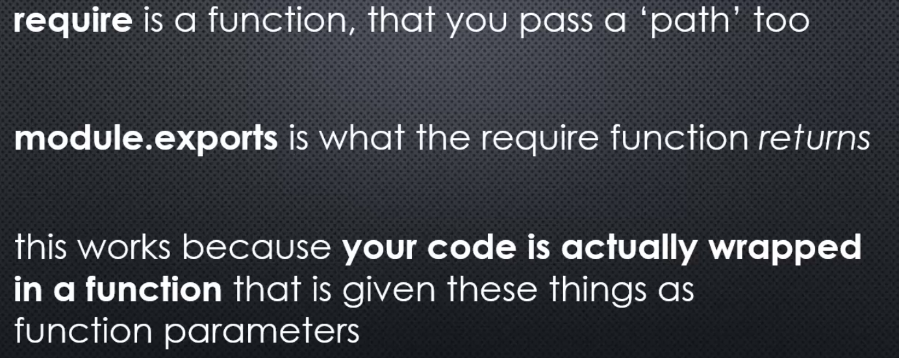

And, this works because your code is actually wrapped in a function, a function expression, that is given these things as function parameters.

So, whenever you're writing code in Node, you have require, you have module. Dirname, filename are always available to you, because what you write isn't the only thing that's given to V8. What you write is actually the body of a function.

## **More on require**

**Is require only able to grab a single JavaScript file?**

**What if the module I want to build is quite large and needs to split into several files?**

**Is there any other kinds of files I can require other than .js files?**

Lets Answer above questions

I'm going to create another greet module. But let's suppose, this time, it's a bit more complex.Maybe I'll greet in multiple languages, and a single JavaScript file just becomes

too difficult to maintain.

**I can require greet, and since there is no greet.js file, the require function will instead look for a greet folder. Then it will look inside that greet folder for a file simply called index.js.**

So if it can't find greet.js it looks for a folder, and it will look for index.js inside of it.

I have a module that I can require with this single line, just say require greet. However, I can now have multiple files inside the greet folder that work together and are ultimately called by index.js.

So, let's build out my module.

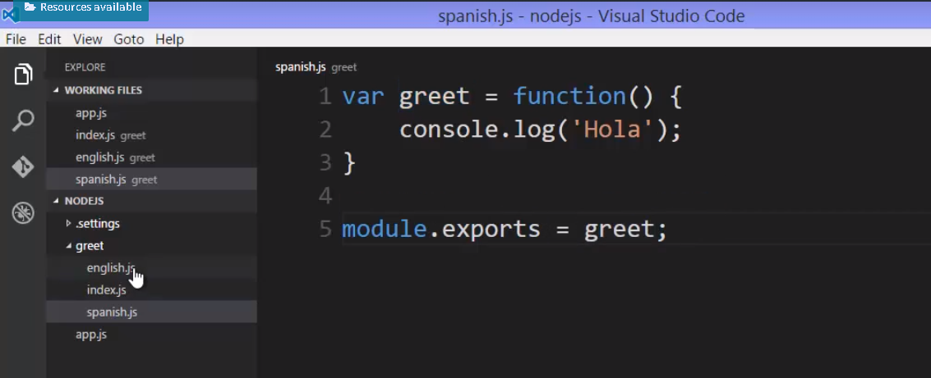

Remember this is wrapped in a function expression so I have a parameter pass to this function,secretly behind the scenes so I can use it.

module.exports = greet;

**Then I want to make this available to use as a complete module. So I can use require inside index.js and then require index.js itself using the greet folder.** 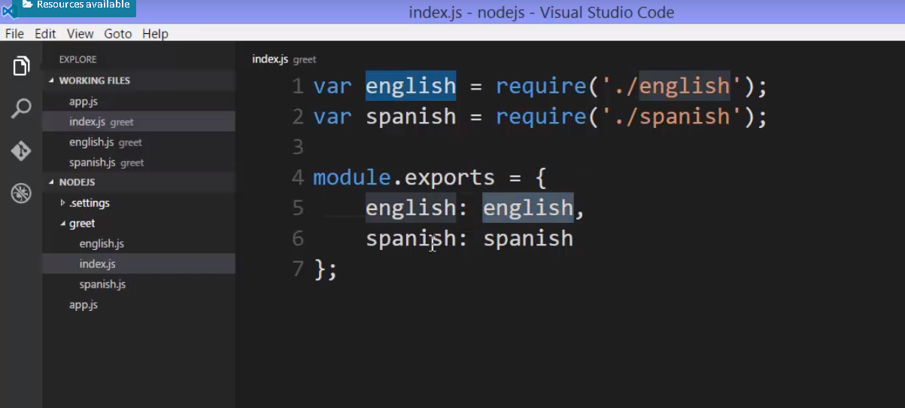

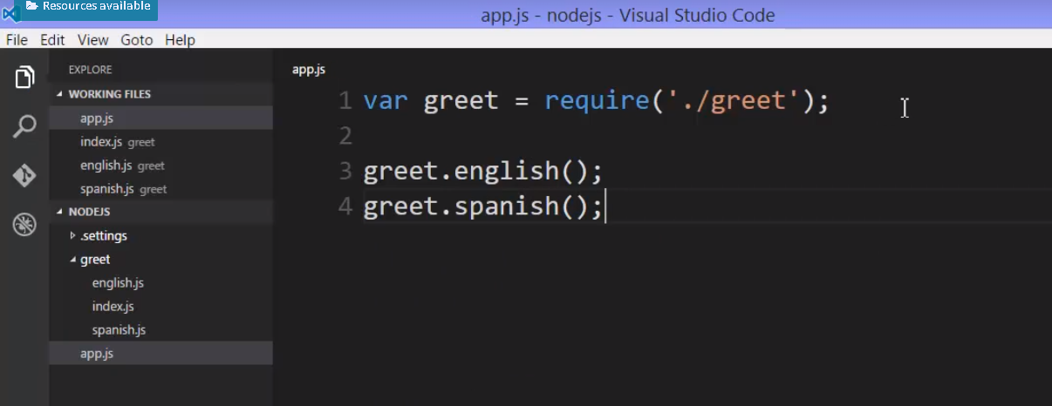

I'll go back to my app.js file, and I'll go require the module.

But there is no greet.js file.

So instead it will grab that folder and look for index.js, run that, and when it runs it, it'll give me back this object. So greet will now be that object, and that object has two methods: greet.english, and I'll do greet.spainish.

Those were the names of the methods that I gave them.

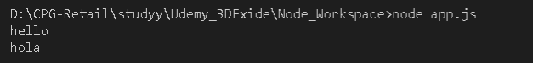

Let's add one more feature.

**And we'll use the ability that the** **require function has with a node to process a .json file.**

Let's go to my folder and add a new file. We'll call it greetings.json. Now a .json file, we mean that it's just holding text that's formatted in the .json format that many programming languages have features to understand and JavaScript understands quite well and can generate.

This isn't JavaScript, this is just text, but JavaScript will be able to read this text and then convert it into a JavaScript object.

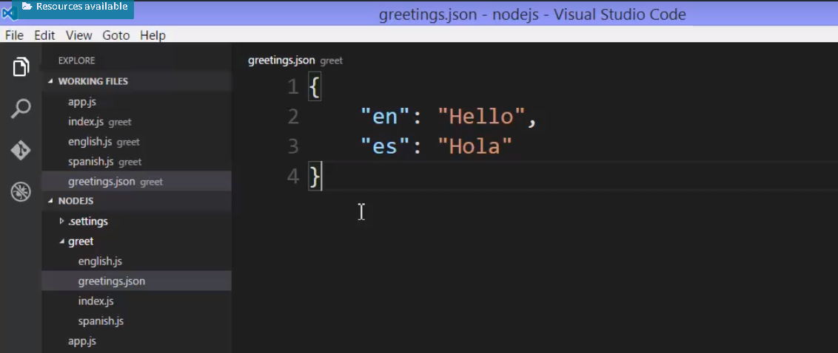

**And JavaScript can read this and convert it into an object much like it does with object literal syntax. The require function will actually do that for me.**

**So I will require my .json file from my javascript file and I will put a breakpoint for debug so that we can see how we are getting data from json file -** 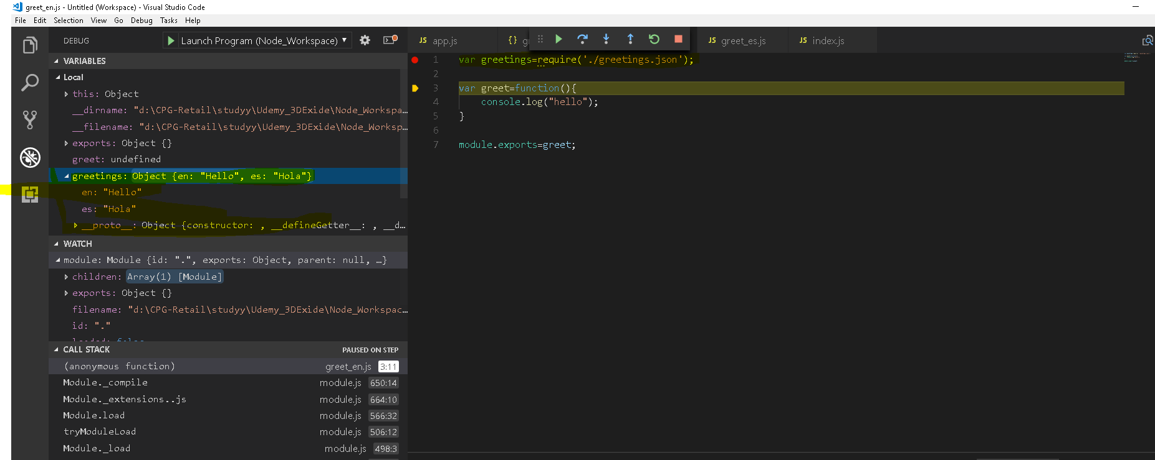

We can use this way –

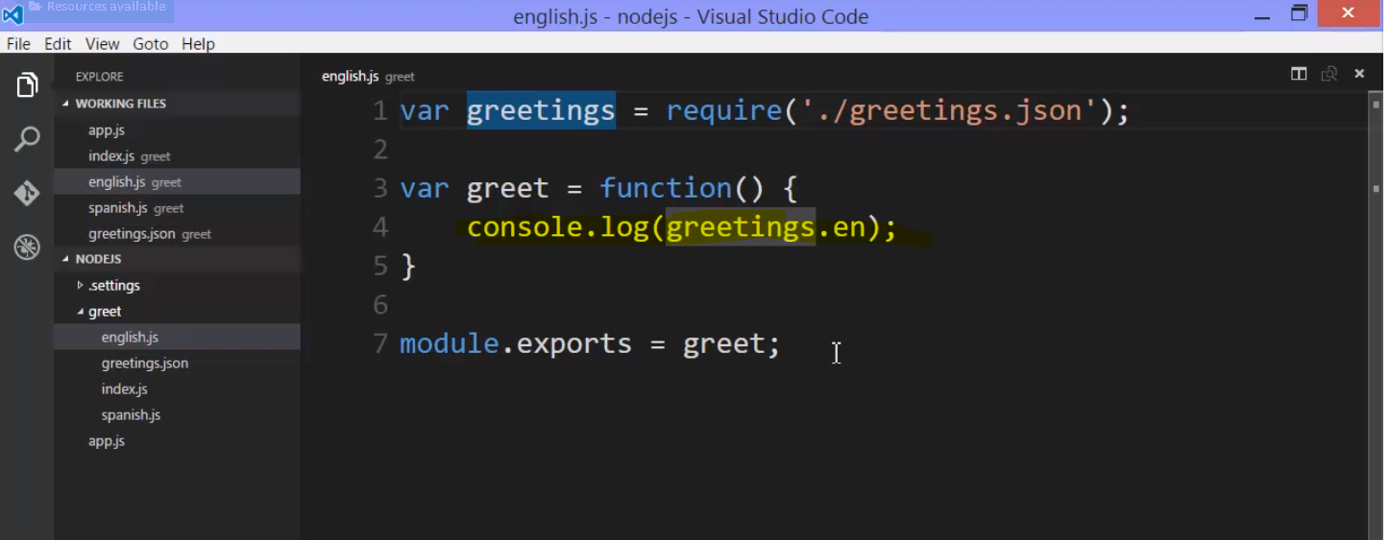

## 26. Module Patterns

let's look at some different ways we can use this feature to structure our modules in Node.js

Now, there's no one right way to do this. It's an architectural choice.

### 1.

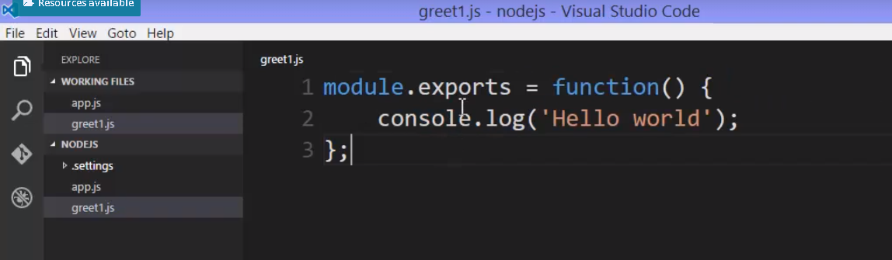

Now notice that exports, when I first get it, is an empty object. What I'm actually doing is overriding it.

**Overriding exports with a function. So we're giving back a single function. And replacing the empty object that we got with the single function.**

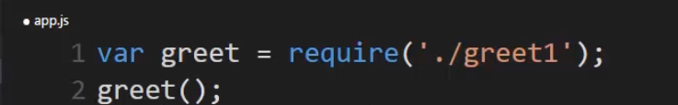

### 2.

And this time, instead of replacing that empty object that's already there for me on the exports property of the module object, I'll just add a new property to that empty object.

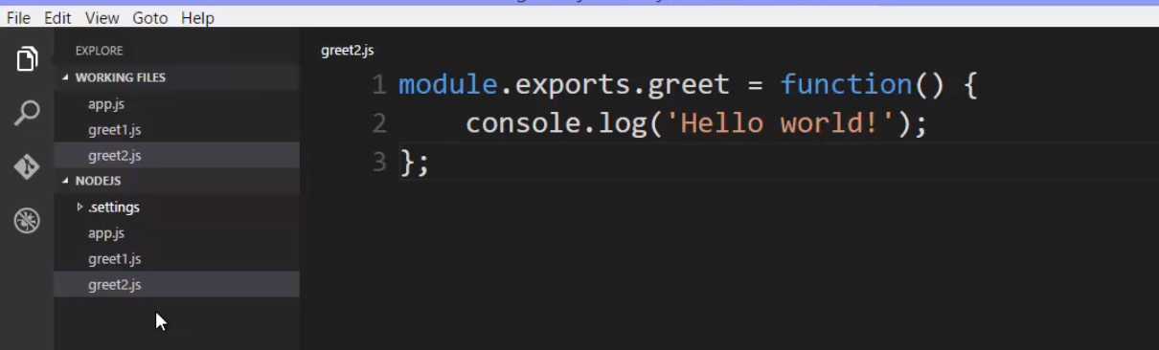

Now, how would I use this when I require this module?

**Well, remember, require returns module.exports. And that will still be an object. It started off as empty but now I've added a new property to it. That's a function so it's a method. I've added a method to the exports object.**

First approach 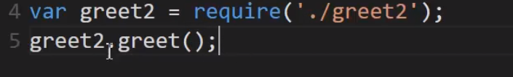

Second approach 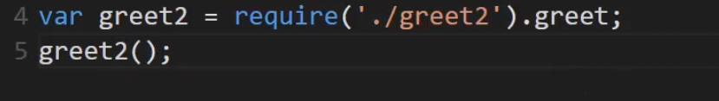

### 3

this time, instead of replacing exports with a function, we're attaching a method to the empty object that export starts its life as.

I'll replace exports with my own object.

To do that, I'll choose to use a function constructor.

**There are a number of ways to create objects in JavaScript. The newest version ES6 ads the class keyword as an option to create objects. There's also something called object.create.**

**I'll just use a regular function constructor**

and I'll add a property to my object called greeting because this keyword points to the newly created object when you use the function as a constructor.

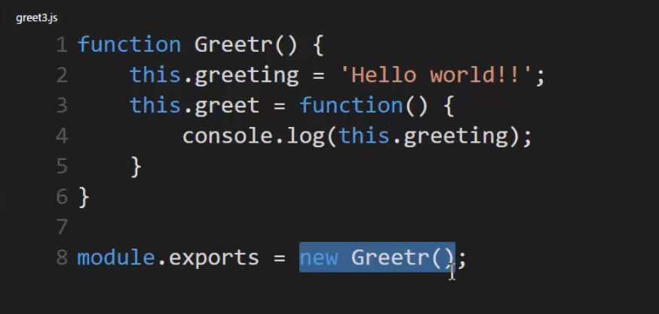

**I'll replace that empty object with my own object. And I'll use new greeter. So I'll use the constructor and create a new object with that constructor, and have exports be that new object.**

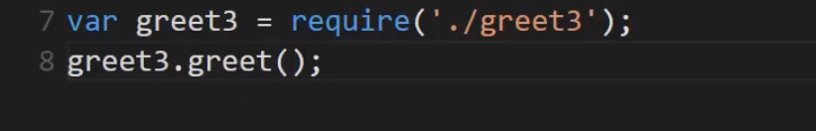

#### **Important Note :**

this actually leads us to something that can cause some confusion when you're using modules in Node.js. Notice that running this code causes module.exports to create a brand new object. That's fairly straight forward.

But here's a question.

What happens if I did something like this? greet3, and greet3b require the exact same file over again.

What will this contain?

A different object, or the same object?

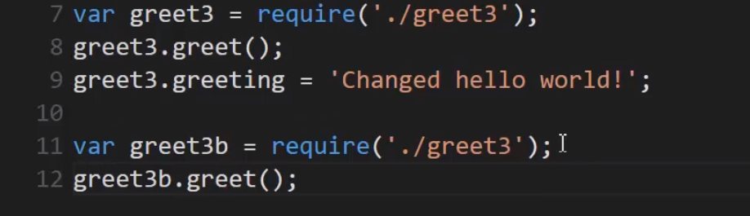

Output - 

And look at that.

**That fourth one, even though I've called require again, greet3b ended up being the same object as greet3.**

Why is that?

To answer that question,

we need to step into the require function one more time.

So I'll set a break point and then debug this. I'll simply let it get the object back the first time we call require and ask for greet3. I'll step over that and then I'll step into the second time that we call require.

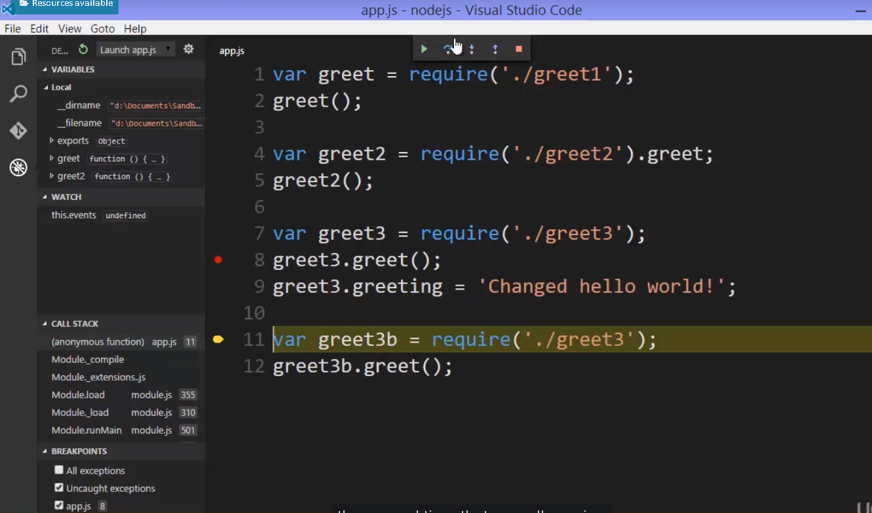

We drop down into the JavaScript code and Node core.

**And notice that there was a spot that we skipped over when we drilled through this before where it looks for a cached module of that particular file name.**

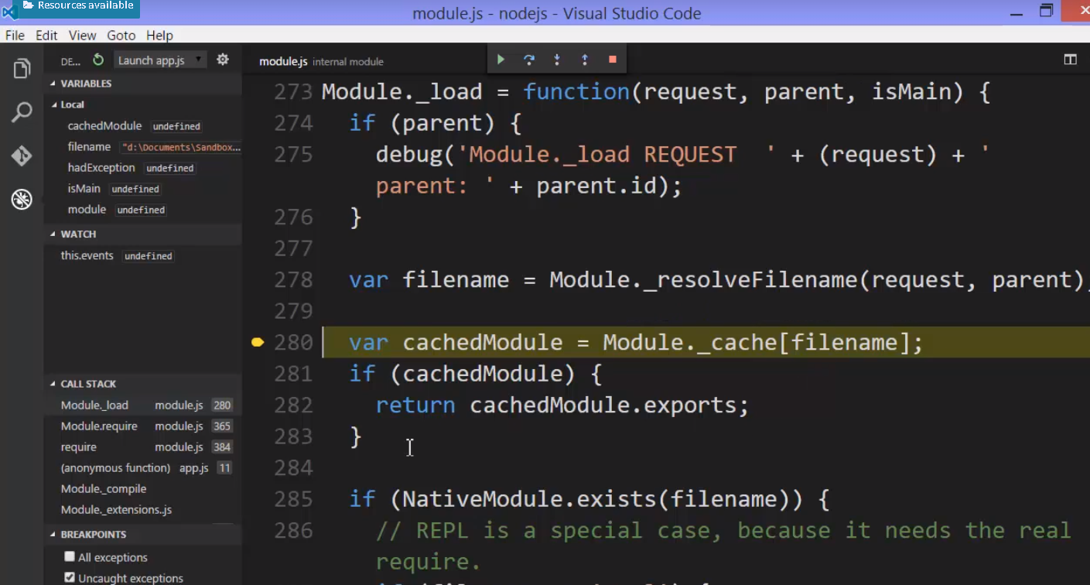

What require does is it actually caches, that is stores, the results of the require function for any particular file name.

So in other words,

whatever I have hanging onto module.exports,I will have in cache here. And then that will be returned instead. because it's an object, it will end up being a reference to the same object that was originally created here, in this initial require call.

**So the first time Node saw the require function being called for this file name, inside the require function, it cached the results. It cached what came back.**

**That is to say module.exports. It saved it.**

**The next time that I called require using that same file name, it went and said, oh I already know what came back in module.exports from that file and I'll just give you that, and since it's an object, it turns out to be a reference so it ends up being the same object, the same location and memory as the other require function.**

**The change that I made to that object is reflected here as well because both greet3 and greet3b end up pointing at the same object.**

That's extremely efficient and also allows me to create a single object that can then be referenced and used in different ways across my application. That turns out to be highly useful .

### 4.

what if I didn't want to have the same object come back from require all the time?

Well I could simply change what I attach to module.exports or what I replace it with.

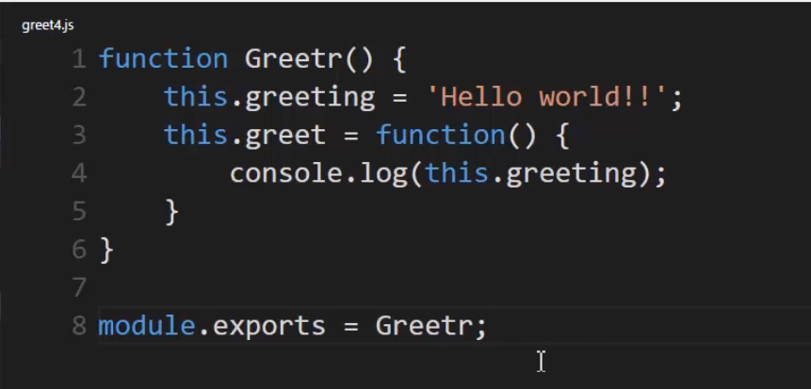

**I'll replace that exports object with the function constructor itself.**

So instead of creating the new object, I'll simply give back for my module, the ability to create the new object.

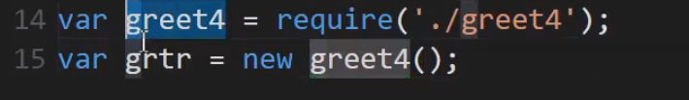

### 5. Revealing Module pattern



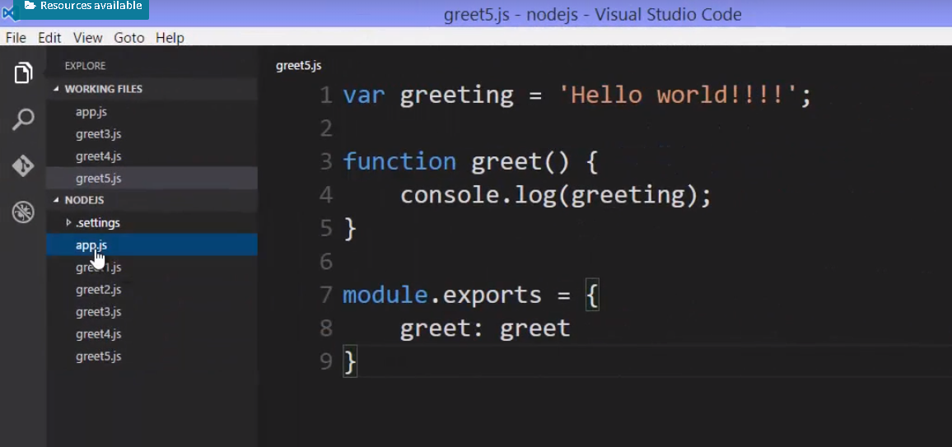

notice there's no way for me to really change the greeting property or access it because it wasn't on the object that was returned. It wasn't revealed to me when I went to use the module via the required function.

**So that greeting variable is protected.**

And this is useful structurally, as are all of these patterns there's no one right way to do this. This is an architectural choice, but you can imagine structuring your modules in various ways depending on how you want them to be used and how you want to use them throughout your application.

**Note :** **remember that if you simply return an object from require, that will be cached**

**and any other call to that same file via the require function will get you back this same object everywhere.**

## Exports vs module.exports

**Remember, when our code is run through Node, it's wrapped in a function expression and so, for that reason, we have access to this module object that's a parameter passed to the function. But if you also remember, there was something else, the first parameter called exports.**

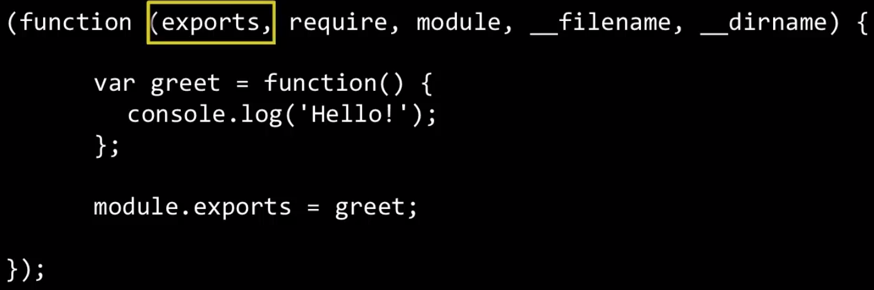

So what is that?

Well, we saw that when the function is executed essentially something like this, these five parameters passed to MyCode, whenever MyCode is run.



The first parameter is module.exports. That's the value passed to the function that wraps my code.

**So really exports, that first parameter, is a shorthand to module.exports. It's two variables pointing at the same object in memory.**

Well, why not just use exports all the time?

however, there's a little bit of a problem and it has to do with a quirk in JavaScript when it comes to objects being passed by reference.

Remember that the require function returns module.exports, so it's really returning the property on a module object, and that's a separate variable from that exports variable,

So we have two variables pointing at the same memory space and so in pass by reference they'll be the same thing.

However, exports does not work for all of the patterns that we've seen so far.

Lets see how –

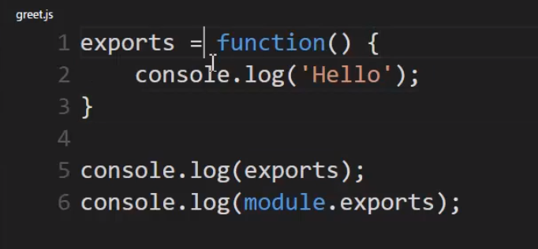

I changed exports from an empty object to a function. So what do you expect would happen here?

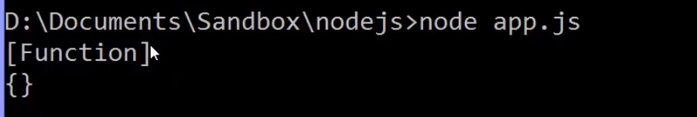

Exports is now a function, but module.exports is still the empty object.

**Now you might have expected that when we set exports equal to the function that module.exports would also change because they're both pointing at the same location in memory.**

**And if you were in a different programming language, you'd probably be right.**

**But this is a quirk in JavaScript.**

What's really happening?

But there's a quirk in JavaScript when it comes to setting the variable equal to a value.

Now in the case of using that equals, we had module.exports pointing at this object still. But exports was set equal to a value, and in JavaScript when a variable is set equal to a value, then it's a new spot in memory. In other words, that reference is broken.

And for that reason, exports and module.exports are two different things.

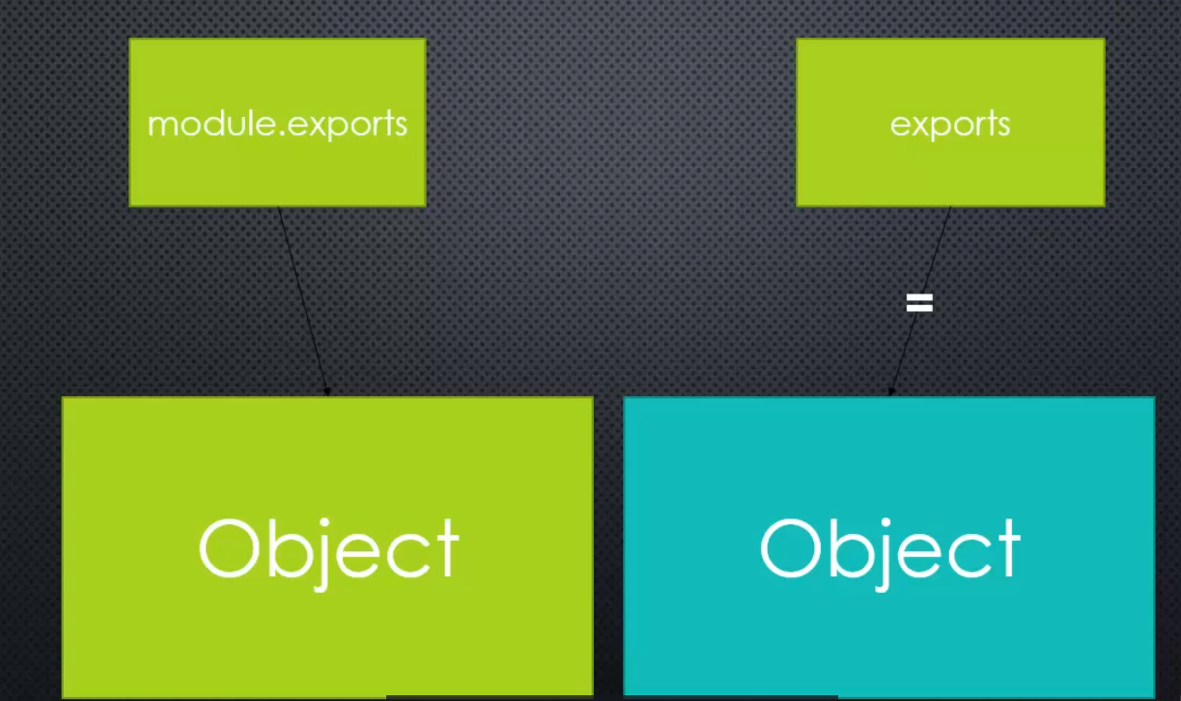

Now here's the kicker, here's the problem.

What's returned from require, module.exports. So since I've just broken that reference, exports will not be returned from here 'cause it now points to a different spot in memory than module.exports.

But **inside the node.js source code, require returns the module objects property called exports**, not this special variable, this parameter that was passed to the function.

So that means if I tried to then invoke the function as if I had done it originally because I exported the function, instead of it just working, I get an error, object is not a function.

Why, because when I go to execute this what I actually got back was module.exports,

that empty object, not the function.

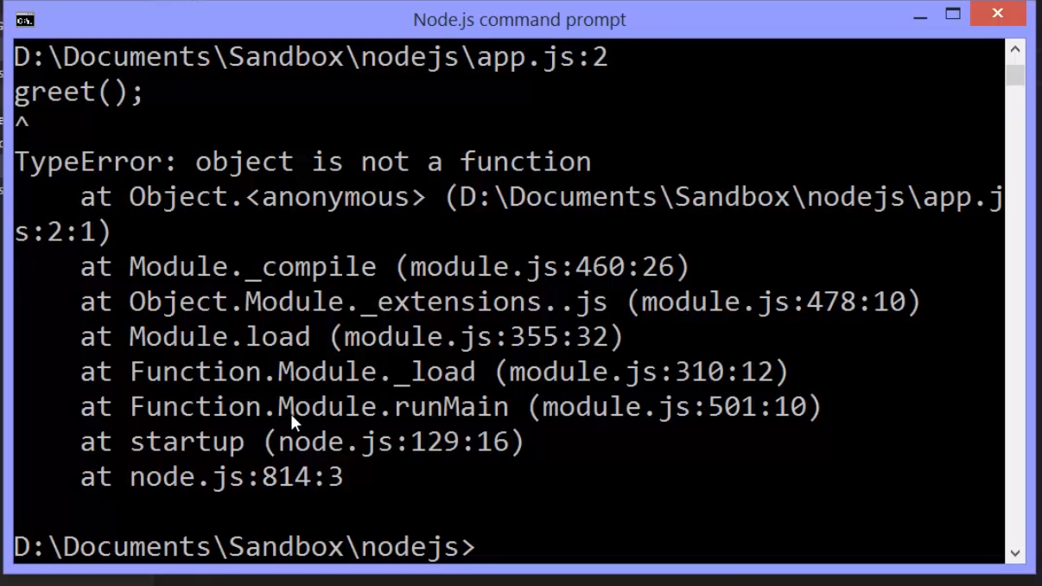

**So when it comes to exports, I can't override it. I can't use equals.**

**However, I can change it. That is to say I can add a new property or a new method. So I can change it. I can what's called mutate it.**

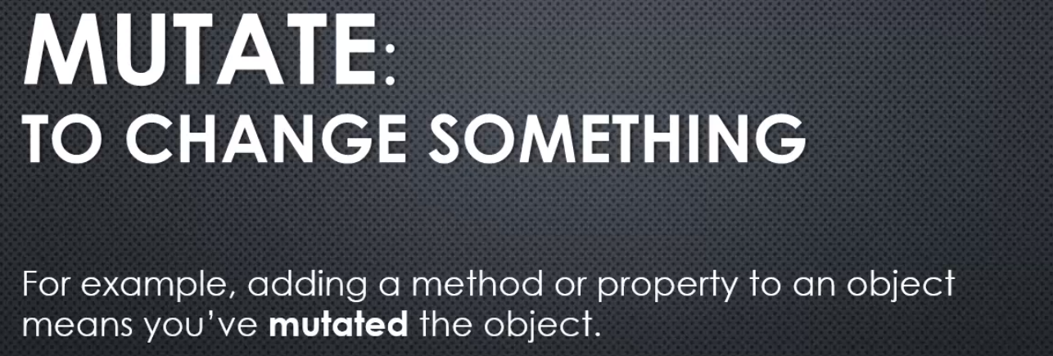

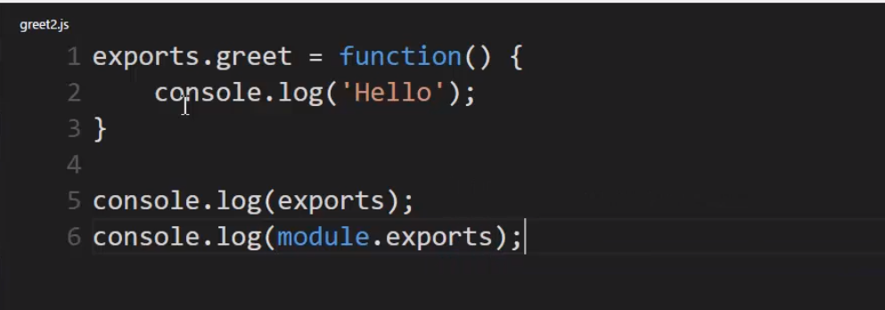

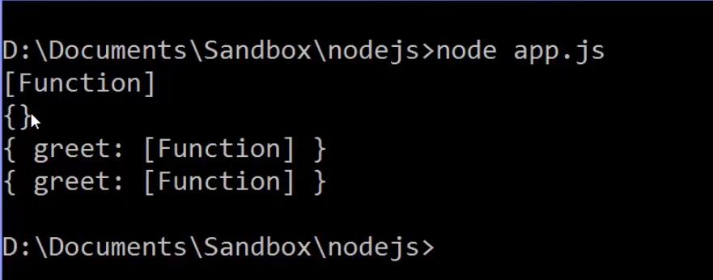

in this case, both exports and module.exports are the same object. See they both have the greet property, the greet method.

So why?

Because I simply mutated. I added, I changed the object, I didn't repoint the variable somewhere, and so the reference held still.

So this is great.

I can use exports if I want to, but only if I mutate the object. I can't replace the object with something else. So you need to be aware of this if you want to use the shorthand.

**Recommentation is to use module.exports**



because I write it so little. I'm only ever going to use it once inside each module that I build, so it's not a lot of typing. And since this is node.js JavaScript, unlike when we do JavaScript in the browser for example, I don't have to worry as much about file size because it's never being downloaded by someone's internet browser. This JavaScript code is sitting on the server.

## 28. Requiring Native(Core) modules

Require that function does more though than just help you grab your own custom modules. Let's look at requiring native or core modules in Node js.

You might have remembered that **module.js** that's what's called when the require function is called.

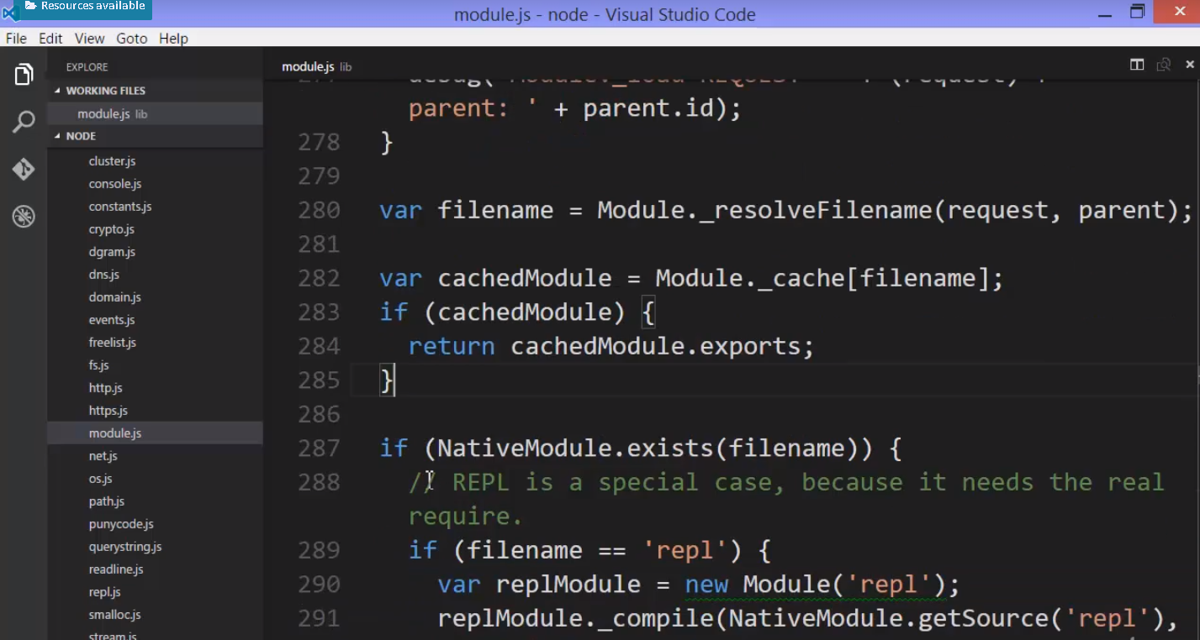

the require function ultimately ends up asking a question. Is the thing you've asked for a native module?

And if it, that's what it actually returns. Otherwise, it then goes and does some other things

**Well a native module is essentially the things that you saw in that lib folder. The javascript core. That javascript side of the code that it comes along for the ride with Node js.**

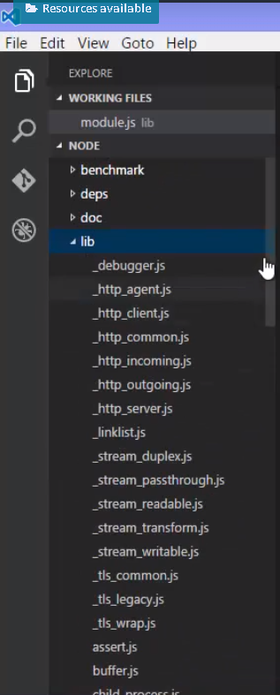

For API documentation - 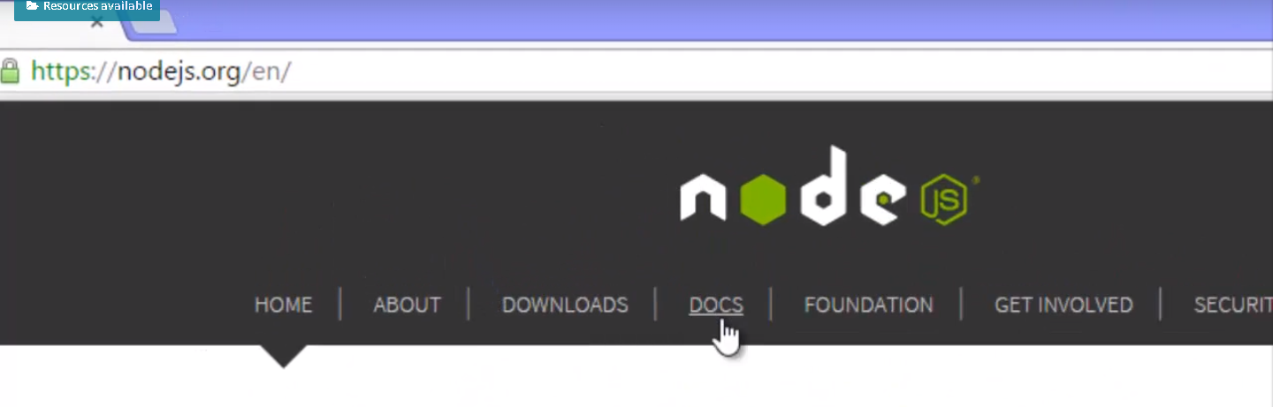

here's the table of content.

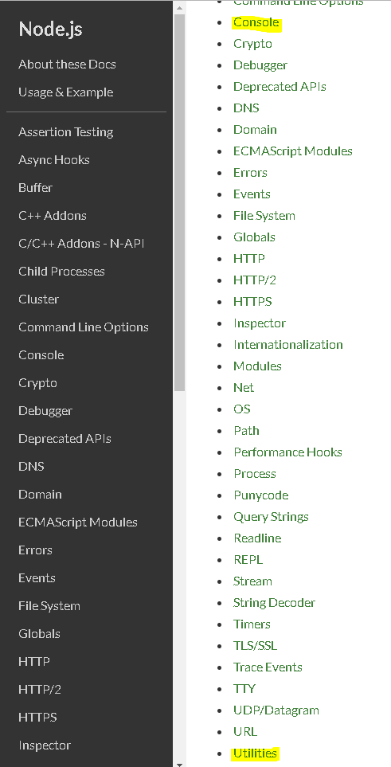

And this shows you the various core modules. The Node API as it's called.

The code that I have available to me, that comes along for the ride in Node that I can use.

They have a variety of features.

For example, we've already used console. So some of them are what's called global, meaning they're just there, like console. I can just use it.

But others aren't global. Like this one: utilities.

How can I use it?

With the require function of course. You should read the API documentation and be familiar with this core code some of this code the things that aren't global?

if require sees that the string that you passed to is a native module, it will use it.

So if I want the utilities I need to require the appropriate thing.

Now you can look this up in the API documentation. And we can see here inside lib, the utilities is util.js. That's in the Node core. And you remember that require will add on the dot js for us.

I don't need the dot slash because the dot slash is telling me to look in the folder that I'm in, that I'm running this programme in.

But instead, I'm just saying: I want this dot js file and if it matches the name of a native js file, then that's what it uses.

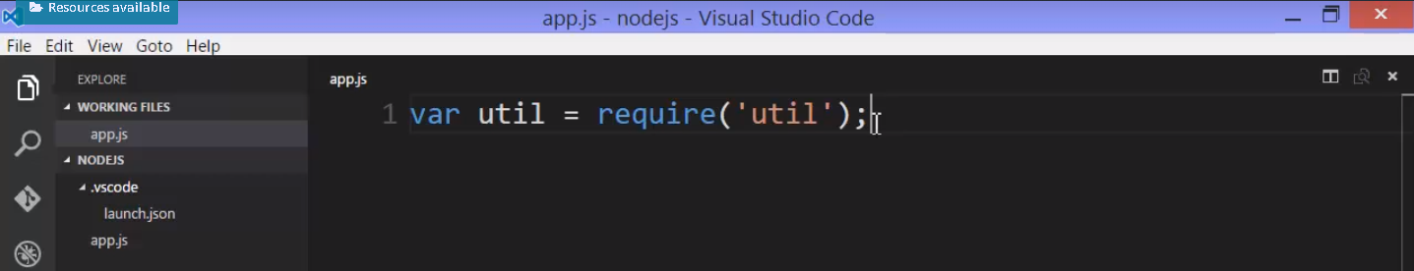

So this is all I need and I now have an object that contains all of the niceties within that utilities feature built into Node.

For example, if you read the API documentation for utilities, you'll see that it has a bunch of methods that have just useful things to make my coding life easier.

Some of those javascript core components as we've talked about before actually are wrappers to calling C++ code, but some of it isn't.

Some of it is just pure javascript code that I could write myself but why bother, because it's already there.

For example, let's say I wanted to build a string.

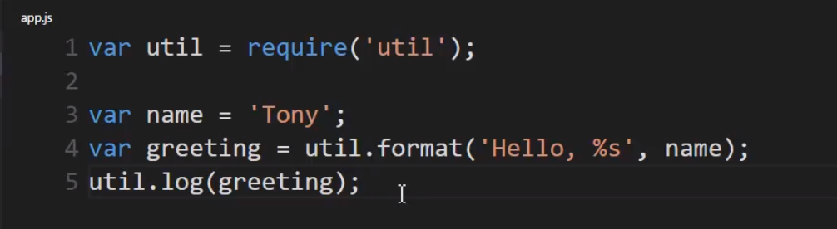

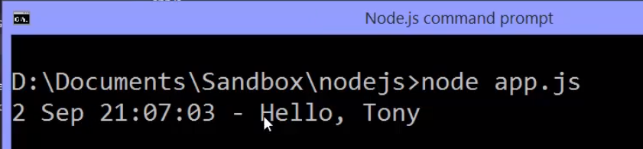

Oh and you might be thinking: what if I name my own custom module the same name as the core js file?

**Well remember if it's custom module you specify the location dot slash or a folder above with dot, dot slash or whatever the case. You're saying that it's local.**

**If you don't then Node is going to look for a native module and some other processes.**

So, it's actually okay if you name it the same but I don't recommend it because you can end up causing yourself confusion between using the core module and your module and back-and-forth, and accidentally type the wrong one.

So I think it's more trouble than it's worth. There's never really a real need to name something the exact same name as a core module. So, personally, I would avoid it.

## 29. Modules and ES6

NodeJS added the idea, the feature, of modules to JavaScript, because it didn't have it.

And you need the ability to separate your code into a modular structure when building large scale software.

The JavaScript specification itself now includes that feature.

The next version of JavaScript, the new version, ECMAScript 2015, or also called ES6,

now has modules built in. That means the JavaScript engines, like V8, are supporting this new module structure.

The new syntax in ES6 for modules is really very powerful and in some ways similar.

For example, if I wanted to export a greet function from my greet.js file, I would put the key word export before the function key word. Then in my app.js file, I can then import anything that has that export tag on it using the import key word.

Now here I'm just using star, but you can actually be more specific. Pull out specific things from the module and even rename them using the as statement. And then you end up with a variable that is the thing that was exported.

So in this way, it works similarly to require and module.exports.

It's very explicit and also in some ways it's a bit more flexible.

The V8 JavaScript engine itself is supporting this concept, not the add-on features from NodeJS.

**So if you see this in code, it's ES6. If you see require and module.exports, it's Node.**

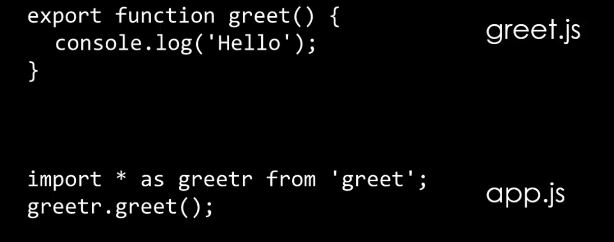

## 30. Web Server checklist

list of some of the things that JavaScript needed

in order to be able to manage a server.

**We've seen that there was various things that JavaScript simply didn't have but that since V8 engine allowed us to expand and add on features to JavaScript, we can add them. And that's what Node.js has done.**

So we can now eliminate Better Ways to Organise Our Code Into Reusable Pieces.

We needed that and we have it. We have it in the forms of modules, using module.exports and require.

So that's one thing down.

